**Output ALV_OOABAP_doubleclick(event handler)**

1. Give a suitable CARRID and Execute .

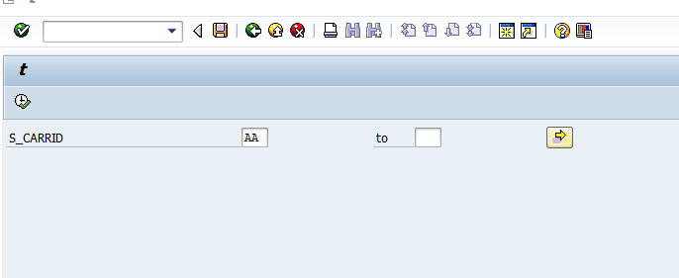

1. Select any record.

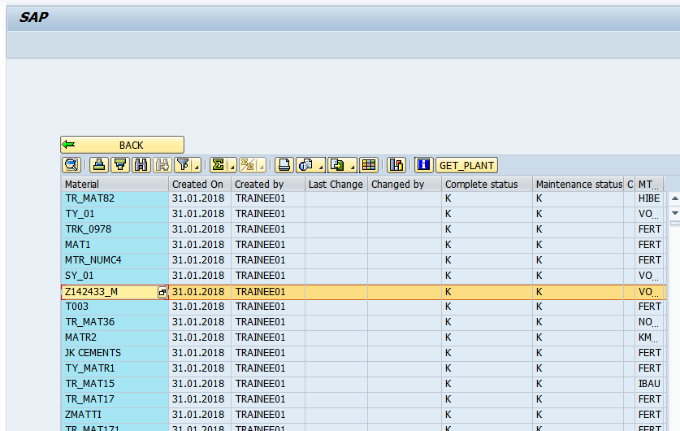

3a) Click on GET PLANTS

3b)Double click any reacord



4a) Output on clicking get plants

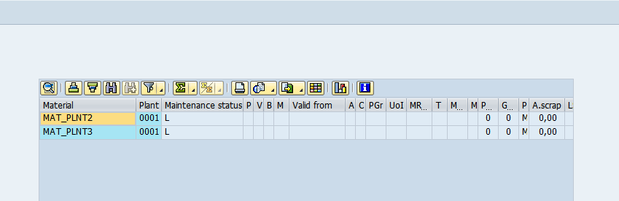

4b)Output:On double clicking

